New Stereoselective Reactions of Rhodium Carbenes for the Assembly of Complex Organic Molecules

Jared T. Shaw

Department of Chemistry, University of California, Davis, CA, USA
jtshaw@ucdavis.edu

Rhodium complexes catalyze the reactions of a wide variety of metal carbenes. We have discovered that carbenes that lack electron-withdrawing groups, also known as “donor/donor” carbenes, exhibit unique reactivity for enantioselective catalysis. We have used this strategy for the synthesis of variety of 5- and 6-membered ring products that are useful for the synthesis of drug discovery lead molecules and natural products.

Biography
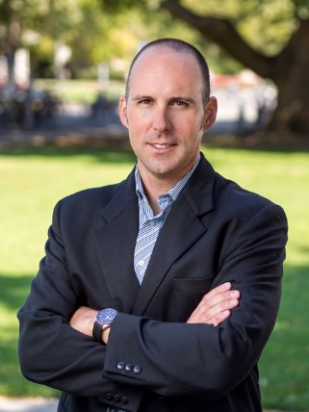
Jared Shaw received his B.S. in chemistry from UC Berkeley (1993), during which time he conducted undergraduate research with Prof. Clayton Heathcock. After working as an associate at Gilead Sciences for one year, Jared entered the Ph.D. program at UC Irvine and worked with Prof. Keith Woerpel, graduating in 1999. Jared then moved to Harvard as an NIH postdoctoral fellow with David Evans. Dr. Shaw became an institute fellow at the Institute for Chemistry and Cell Biology (ICCB) at Harvard Medical School in 2002 where he helped found the Center for Chemical Methodology and Library Development (CMLD) in 2003, which later became part of the Broad Institute of Harvard and MIT. In July of 2007, Jared joined the faculty of the University of California, Davis as an assistant professor. He was promoted to associate professor in 2012 and to full Professor in 2016. He currently works on the development of new methods for the synthesis of natural products and other complex molecules that modulate biological phenomena, with a specific emphasis on the discovery of new compounds with the potential to become antibiotics to treat infections that are resistant to current therapies.

